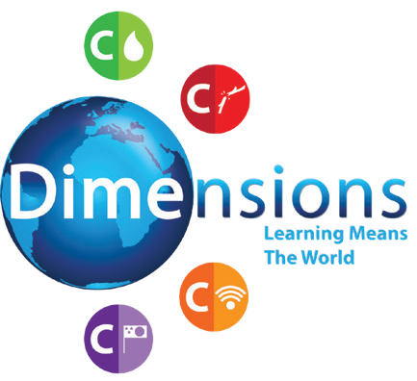

Curriculum Newsletter
Cosmopolitan

Theme Overview
“Cosmopolitan” is a thematic unit, based on New York, USA and Sydney, Australia, with a key focus on geography and history.

Maths

In maths we will be learning about fractions and multiplication and division.
Art
In art we will be learning the skills to create paintings inspired by the work of John Curtis.
We will be writing in a number of different text types some linking to our new curriculum.
Literacy

Science
In Science we are studying the properties of materials with a focus on cotton.
Design Technology
In DT we will be focusing on designing and construction looking at architecture and buildings.

© Dimensions Curriculum Ltd.
Wish you’d... develop tolerance

Curriculum Newsletter
Cosmopolitan

Drama
In drama we will be looking at freeze frame and retelling a real life story

Music
In music we will be learning the English and Australian National Anthems

PSHE
In PSHE we will be developing skills including listening, communication and celebrating diversity.

Computing
Spreadsheets
In computing we are learning how to use spreadsheet software to collect, store, analyse and represent data.

© Dimensions Curriculum Ltd.
Wish you’d... develop tolerance

